Assignment - 3

|  |  |
| --- | --- |
| Assignment Date | 02 November 2022 |
| Student Name | Siva.A |
| Student Roll Number | 610919104082 |
| Maximum Marks | 2 Marks |

1. Create a bucket in object storage.

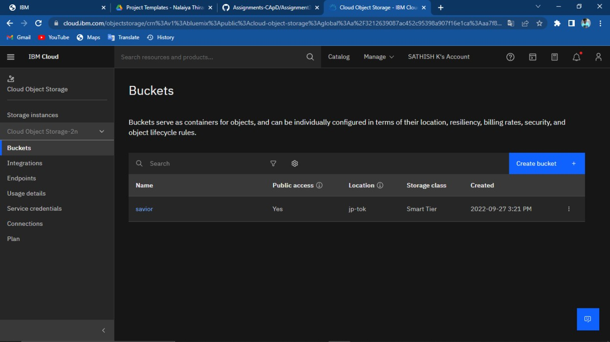

1. Upload an 5 images to ibm object storage and make it public .Write html code to displaying the all 5 images.

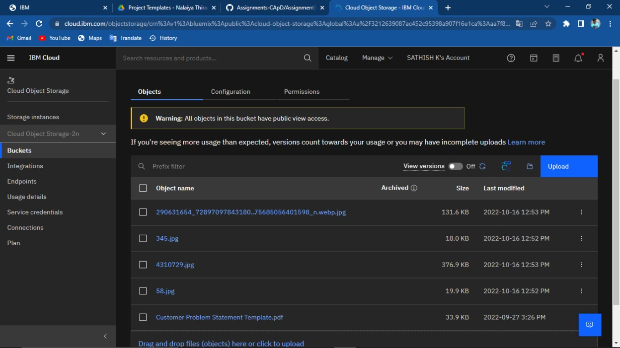

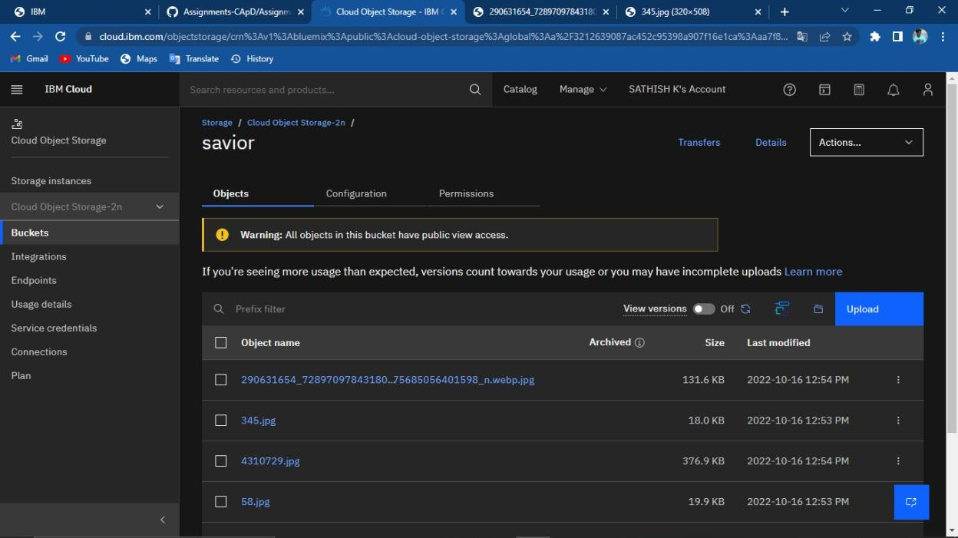

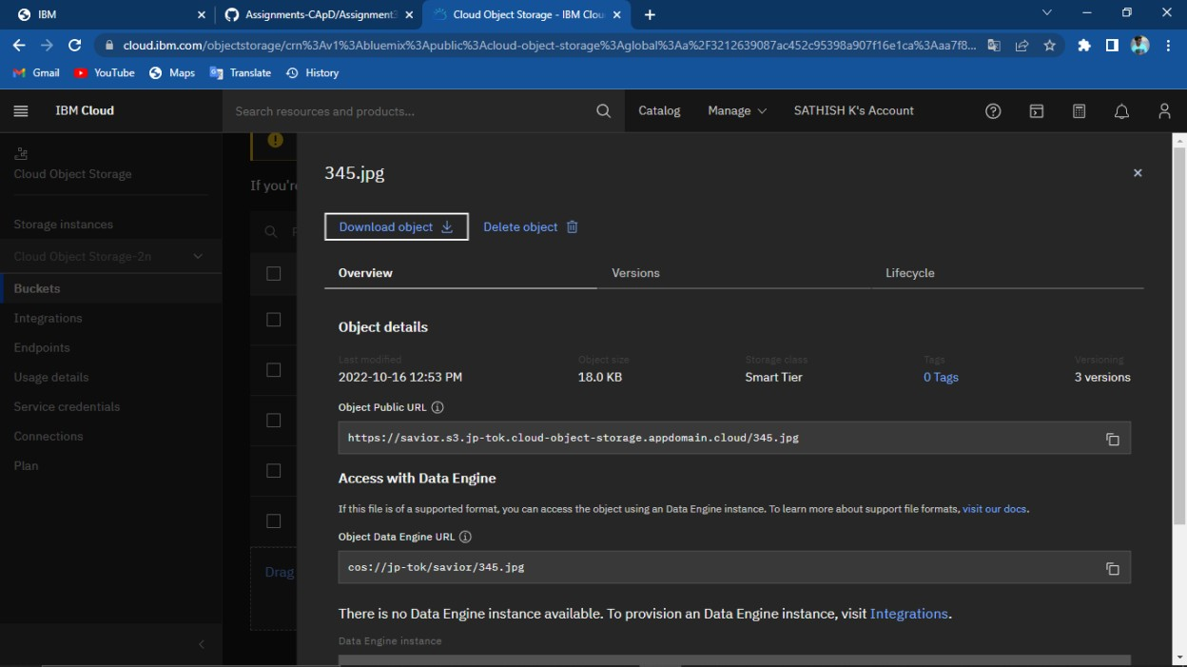

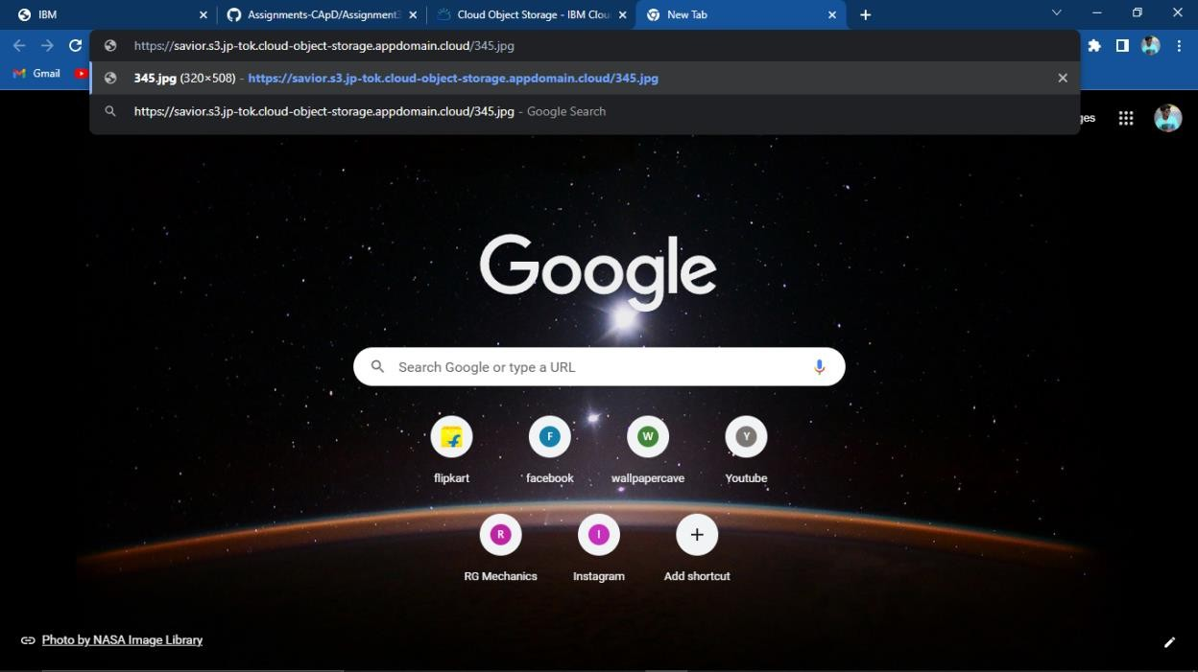

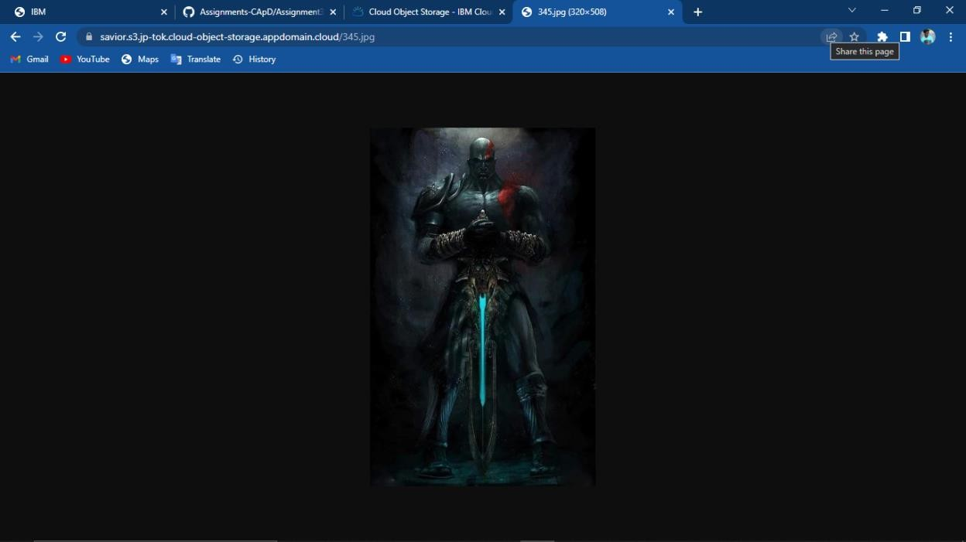

Html code:

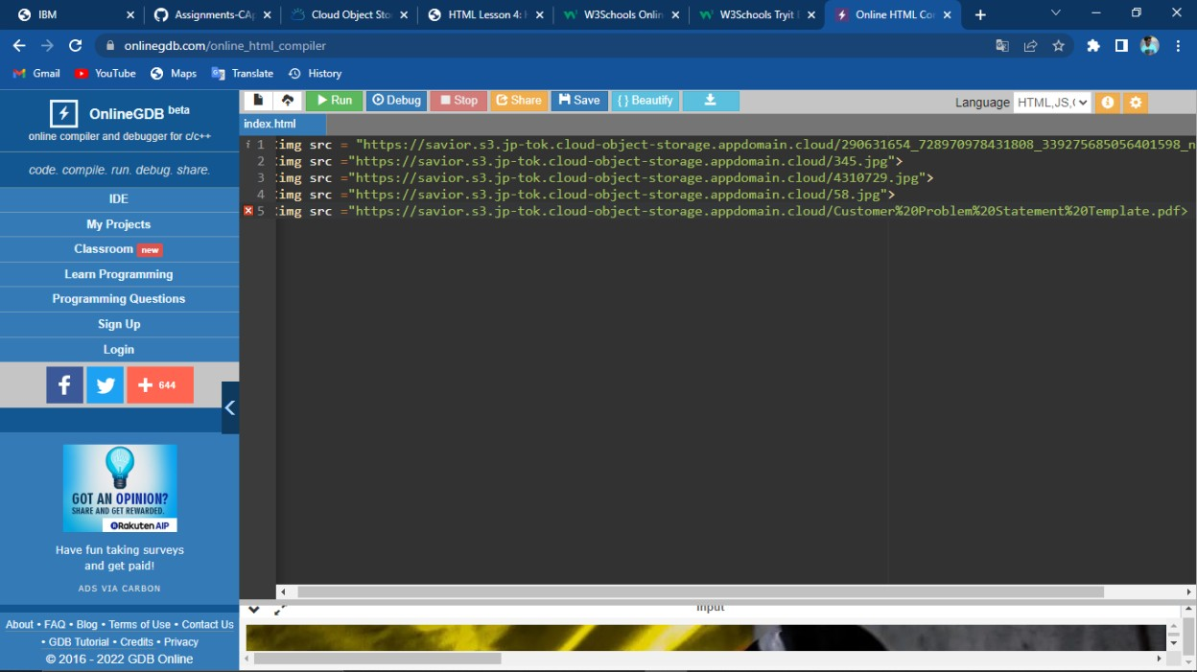

Output:

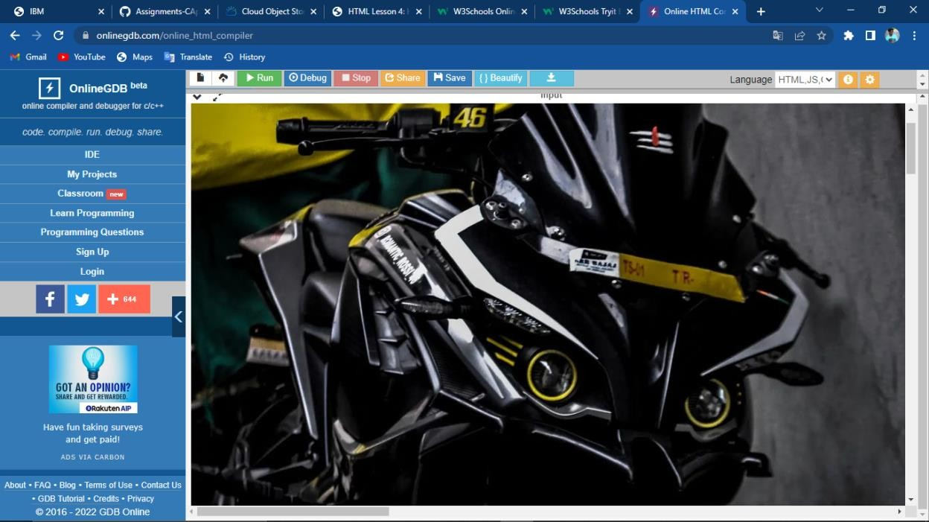

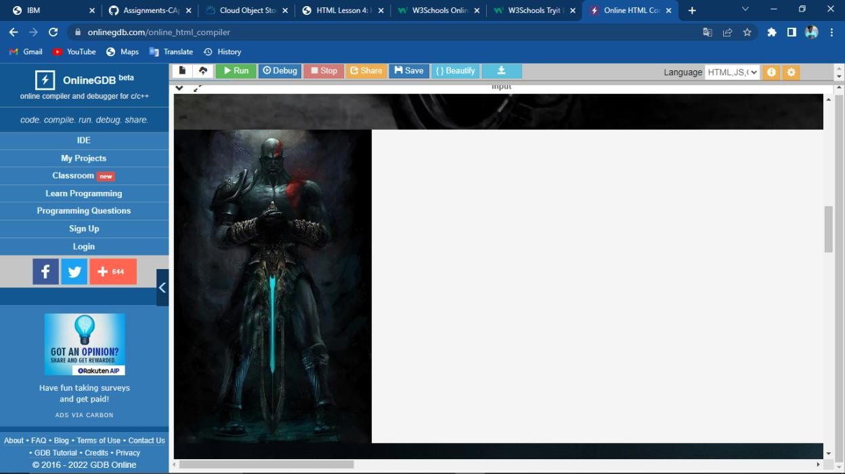

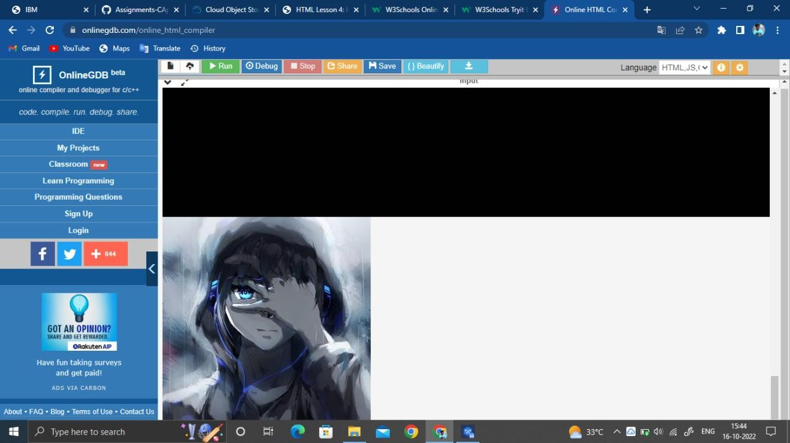

1. Upload css page to the object storage and use the same page in your html code. Css template:

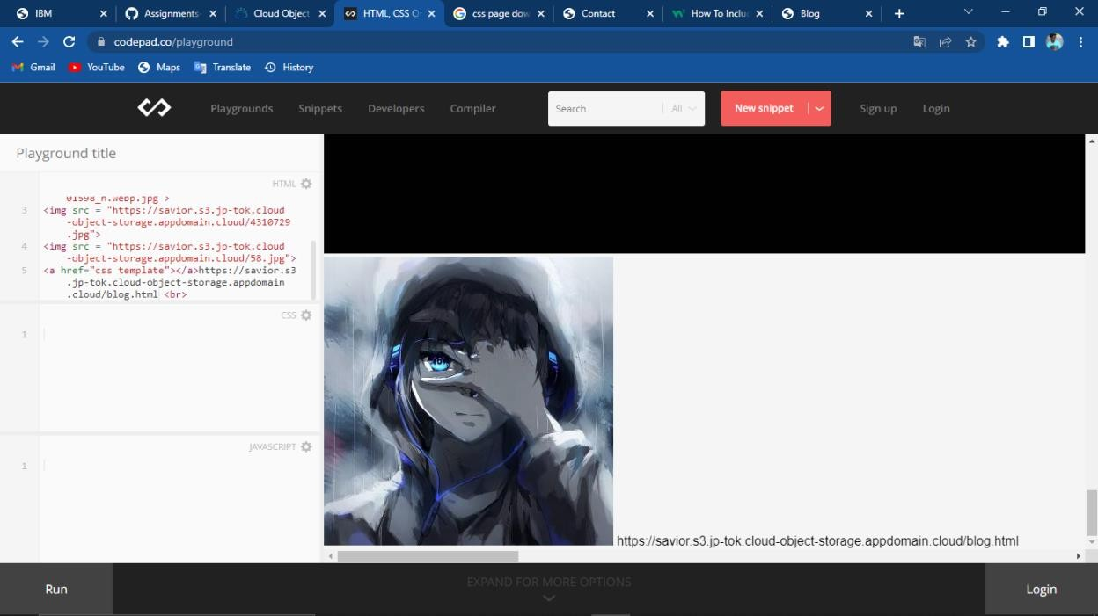

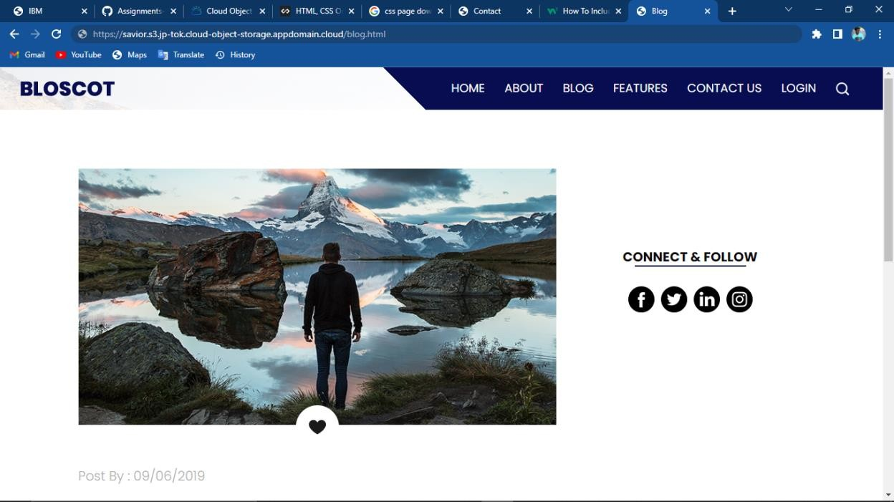

1. Design a chatbot using IBM Watson assistant for hospital.

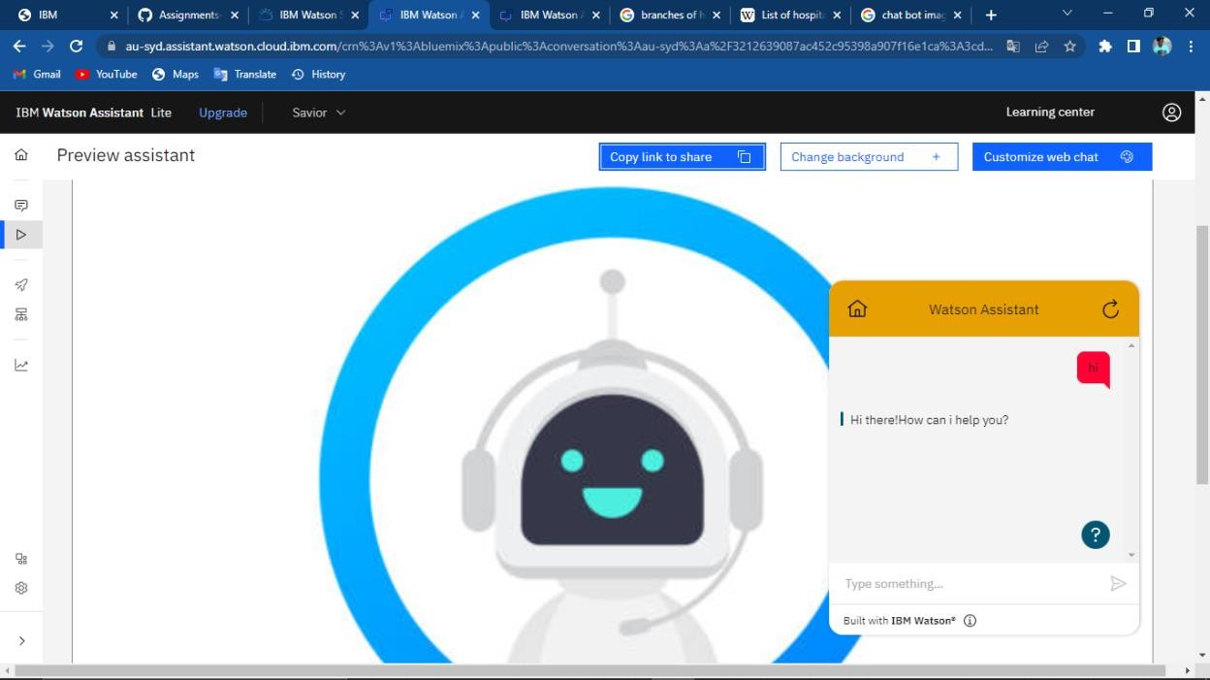

Chat bot link:

https://web- chat.global.assistant.watson.appdomain.cloud/preview.html?backgroundImageUR L=https%3A%2F%2Fau- syd.assistant.watson.cloud.ibm.com%2Fpublic%2Fimages%2Fupx-3cd655a1- 1b78-48dc-ab20-337c94b88647%3A%3Ade7378dc-1145-4a02-a22b-

c41465415808&integrationID=090b01c7-21ab-41fa-9911- bea3a93c7f8e&region=au-syd&serviceInstanceID=3cd655a1-1b78-48dc-ab20- 337c94b88647

1. Create watson service assistant with 10 steps and use 3 conditions in it. Load that script in that HTML page.